**5: Verify AWS LBC Deployment and WebHook Service**

**Verify that the controller is installed and Webhook Service created**

**# Verify that the controller is installed.**

--- **kubectl -n kube-system get deployment**

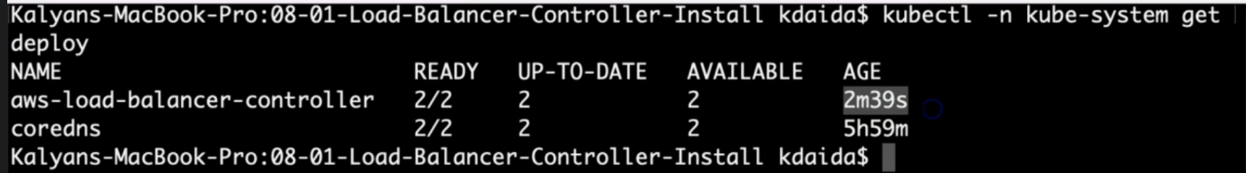

--- **note** - aws-load-balancer-controller is created 2m39s before.

--- **kubectl -n kube-system get deployment aws-load-balancer-controller**

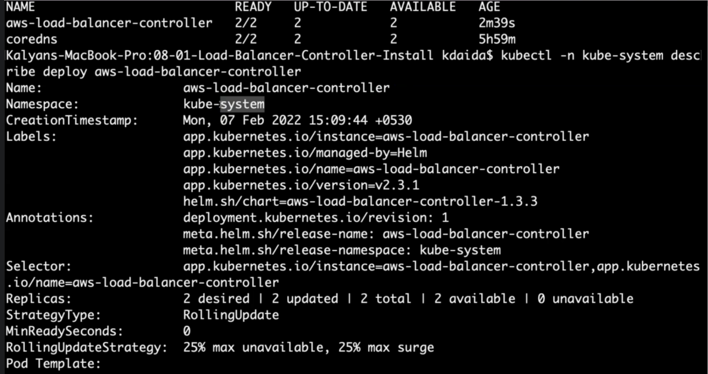

--- **note** – under the label section, you are going to see that the version it is installed. You have read the selector section also.

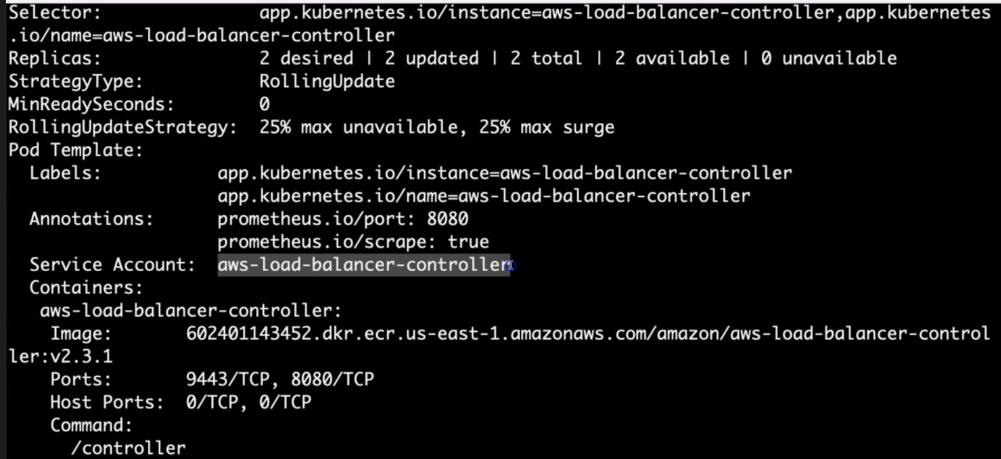

--- **note** – replicas desired is 2, strategytype is rollingupdate, service account is aws-load-balancer-controller.

--- **kubectl -n kube-system describe deployment aws-load-balancer-controller**

**# Sample Output**

Kalyans-MacBook-Pro:08-01-Load-Balancer-Controller-Install kdaida$ kubectl get deployment -n kube-system aws-load-balancer-controller

NAME READY UP-TO-DATE AVAILABLE AGE

aws-load-balancer-controller 2/2 2 2 27s

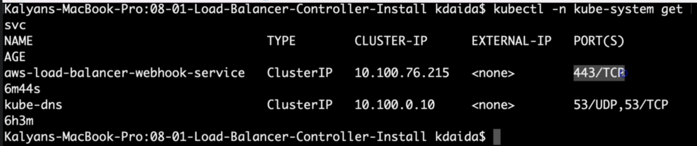

--- **note** - there are 2 service it displayed under the kube-system name space account. The aws-load-balancer-webhook-service is listening on port 443.

**# Verify AWS Load Balancer Controller Webhook service created**

--- **kubectl -n kube-system get svc**

--- **kubectl -n kube-system get svc aws-load-balancer-webhook-service**

--- **kubectl -n kube-system describe svc aws-load-balancer-webhook-service**

**# Sample Output**

--- **kubectl -n kube-system get svc aws-load-balancer-webhook-service**

NAME TYPE CLUSTER-IP EXTERNAL-IP PORT(S) AGE

aws-load-balancer-webhook-service ClusterIP 10.100.53.52 <none> 443/TCP 61m

**# Verify Labels in Service and Selector Labels in Deployment**

--- **kubectl -n kube-system get svc aws-load-balancer-webhook-service -o yaml**

--- **kubectl -n kube-system get deployment aws-load-balancer-controller -o yaml**

--- **Observation:**

1. Verify "spec.selector" label in "aws-load-balancer-webhook-service"

2. Compare it with "aws-load-balancer-controller" Deployment "spec.selector.matchLabels"

3. Both values should be same which traffic coming to "aws-load-balancer-webhook-service" on port 443 will be sent to port 9443 on "aws-load-balancer-controller" deployment related pods.

---